## OFFICIAL-SENSITIVE

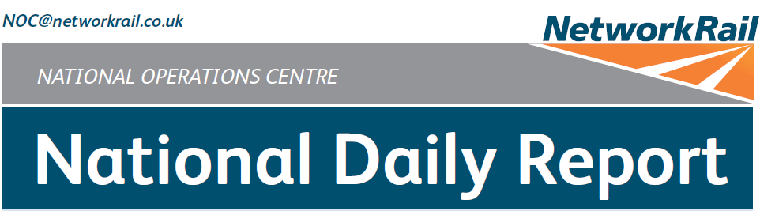



***DATE OF REPORT: NOC MANAGER 0630 – 1830:***

***NOC MANAGER 1830 – 0630:***

***DUTY CONTROLLER 0630 – 1830:***

***DUTY CONTROLLER 1830 – 0630:***

***SUPPORT CONTROLLER 0630 – 1830:***

***SUPPORT CONTROLLER 1830 – 0630:***

***LONDON CONTROLLER 0700 – 1900:***

***LONDON CONTROLLER 1900 – 0700:***

***Monday 4th May 2020 Paul Dellow Uncovered***

***David Wiltshire Jason Purdie Karl Biswell***

***Graham McIntosh Dominic Duggan Keith Stokes***

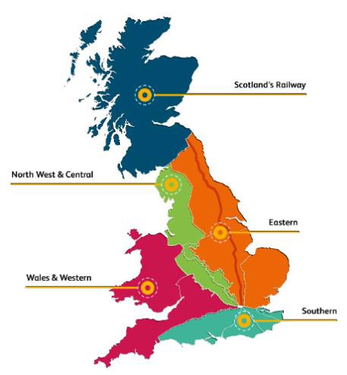

## OFFICIAL-SENSITIVE

Page 1 of 10

***CONTENTS***

### COVID-19 3

### INJURIES & ASSAULTS 4

### SIGNALS PASSED AT RED (CATEGORY ‘A’) 4

### WRONG SIDE FAILURE REPORTS 4

### DERAILMENTS & COLLISIONS 4

### TRAIN OR VEHICLE RUNAWAY / DIVIDED TRAIN 4

### IRREGULAR WORKING 4

### NEAR MISSES 5

### FATALITIES 5

### INFRASTRUCTURE FAILURES / DEFECTS 6

### TRAINS WITH STRANDED PASSENGERS 7

### WILD REPORTS & HABD ACTIVATIONS 7

### GROUP STANDARDS RIS-8250-RST & RIS-3350-TOM 8

### MISCELLANEOUS 8

### REVIEW TABLE 9

### REAL TIME PERFORMANCE FIGURES 10

***01 COVID-19***

**Total UK COVID-19 Cases** Data as of Monday 4th May 2020

Staff cases:

**Total UK cases**

# 190584

**Daily Confirmed Cases**

# 3985

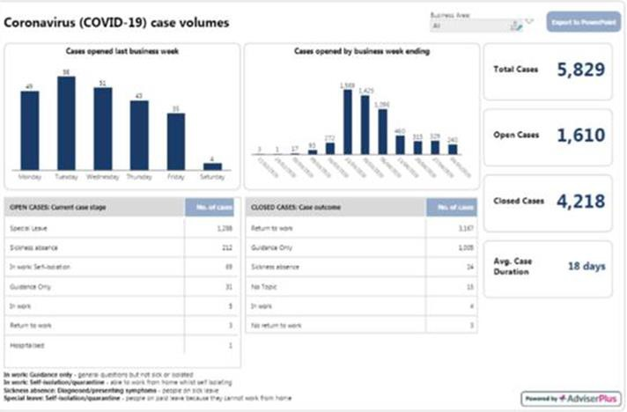

The latest Network Rail guidelines can be found at: <https://networkrail.sharepoint.com/sites/myconnect/news/Pages/STE/News/Novel-Coronavirus.aspx>)

None.

***02 INJURIES & ASSAULTS***

***03 SIGNALS PASSED AT RED (CATEGORY ‘A’)***

None.

***04 WRONG SIDE FAILURE REPORTS***

None.

***05 DERAILMENTS & COLLISIONS***

None.

***06 TRAIN OR VEHICLE RUNAWAY / DIVIDED TRAIN***

Please refer to Report Section 07 for details of a train division between Kirkhill and Newton.

***07 IRREGULAR WORKING***

### Eastern (East Coast) – CCIL 2127152

At 0028 (Mon), the Shift Signalling Manager at Sheffield sub ROC reported an irregularity within the limits of LNEC WON 05, item 246, Howden LC (CCTV) and Hessle East Junction, all lines blocked, 0020 (Mon) – 0500 (Mon), an LNE Network Operations North managed possession. Whereas a Line Blockage was still in place within the limits at the time the possession was granted, the Brough signaller (Intermediate Signaller) had not been notified to ensure the line was clear and the EPR’s were in place. The Shift Signalling Manager further advised that the Line Blockage had been cancelled and the PICOP was stood down and a Mobile Operations Manager commenced the investigation. The on call Local Operations Manager authorised the staff to continue with their duties, following the initial investigation the possession was granted at 0157.

### Scotland’s Railway (Scotland) – CCIL 2127183

At 0110 (Mon), OLE staff carrying out patrolling work within SC WON 05, Item 205, Drumgelloch – Helensburgh Central, 0100 (Mon) to 0410 (Mon) observed that earthing straps were not applied correctly to the return conductor on the Up Airdrie line at Charring Cross. All works were stopped, and arrangements were made for the earths to be applied correctly, this was achieved at 0120. The Nominated Person employed by Network Rail advised that the earths had been applied by their assistant employed by SWGR, who was relieved of duty for interview and ‘for cause’ screening.

***07 IRREGULAR WORKING (CONT)***

### Scotland’s Railway (Scotland) CCIL 2127319

At 1217, the driver of 2M94, ScotRail, 1145 Glasgow Central – Newton formed of units 320307 & 318254, comprising six coaches in total, reported an unsolicited brake demand between Kirkhill – Newton. Acting on the advice of the maintenance control, the driver isolated the relevant safety systems to obtain brake release and moved forward, but failed to check that the train was complete. Upon arrival at Newton, the driver reported that only the leading unit was present, with the rear unit left stranded between Kirkhill and Newton. No passengers were onboard. The rear unit left behind was taken forward by a relief driver at 1325. The RAIB were notified by the NOC at 1348.

|  |  |  |  |  |  |  |  |
| --- | --- | --- | --- | --- | --- | --- | --- |
| TRUST 942998 MHAS | | | | | | | |
| Cancelled | 3 | Part Cancelled | 2 | Trains Delayed | 1 | Minutes | 15 |

### North West and Central (NW) – CCIL 2127422

At 1755, the signaller at Baguley Fold Signal Box inadvertently replaced BF18 signal on the Up Ashton Line at Baguley Fold Junction to red in front of 1F72, TransPennine Express, 1502 Newcastle Central – Liverpool Lime Street. The driver was unable to stop and passed the signal at red. The driver was fit to continue when the circumstances were explained.

|  |  |  |  |  |  |  |  |
| --- | --- | --- | --- | --- | --- | --- | --- |
| TRUST 943316 OQF3 | | | | | | | |
| Cancelled | 0 | Part Cancelled | 0 | Trains Delayed | 1 | Minutes | 5 |

***08 NEAR MISSES***

### Wales and Western (Wales) – CCIL 2127354 / Fault No. 366041

At 1443, the driver of 1V93, Transport for Wales, 1232 Manchester Piccadilly – Milford Haven, reported a near miss near Dinmore tunnels, near Leominster, with a person and their dog walking on the track. The driver stopped the train to investigate, but reported at 1452 that they could found no trace of the person. The driver was fit to continue, following train cautioned reported nothing amiss. The BTP (ref. 162) were advised.

|  |  |  |  |  |  |  |  |
| --- | --- | --- | --- | --- | --- | --- | --- |
| TRUST 943154 XQWS | | | | | | | |
| Cancelled | 0 | Part Cancelled | 0 | Trains Delayed | 4 | Minutes | 43 |

***09 FATALITIES***

### Eastern (East Coast) – CCIL 2127222

At 0621, the driver of 2C00, Northern Trains Limited, 0542 Sheffield – Scarborough, reported that they had seen a person hanging from the footbridge at Kirk Sandall station. All lines were blocked, Emergency services and Network Rail staff attended at 0640. Due to the nature of the incident, Scene of Crime Officers (SOCO) were sent to site, arriving at 0720. Hull services were diverted via Selby. The BT Police (ref. 36) reported at 0801 that they had deemed the incident a non-suspicious death. All lines were reopened from 0847.

|  |  |  |  |  |  |  |  |
| --- | --- | --- | --- | --- | --- | --- | --- |
| TRUST 942620 XQIA | | | | | | | |
| Cancelled | 0 | Part Cancelled | 1 | Trains Delayed | 3 | Minutes | 24 |

***10 INFRASTRUCTURE FAILURES / DEFECTS***

### Eastern (Anglia) – CCIL 2127280 / Fault No. 309122

At 1004, the driver of 2N37, Arriva Rail London, 0909 Richmond – Stratford reported a change of aspect, from double yellow to red, at NL1010 signal on the Up North London Line between Hampstead Heath and Gospel Oak. The driver was unable to stop and passed the signal at red. The driver was fit to continue. Axle counters ‘AER’ and ‘AES’ remained occupied after the incident, and upon investigation it became evident that the axle counters had failed as 2N37 approached the section. Services were authorised passed NL1012 and NL1010 signals at red whilst S&T staff investigated the fault. By 1126, S&T staff had changed a serial card, clearing the fault. Aspect restrictions were removed by passing services at 1145, allowing normal signalling to resume.

|  |  |  |  |  |  |  |  |
| --- | --- | --- | --- | --- | --- | --- | --- |
| TRUST 942855 IQHP | | | | | | | |
| Cancelled | 0 | Part Cancelled | 4 | Trains Delayed | 28 | Minutes | 366 |

### North West & Central (NW) – CCIL 2127401 / Fault No. 889829

At 1652 A.C. Electrical section PW6 tripped and would not reset, affecting the Down Ditton line between Weaver Junction and Ditton. 1F39, West Midlands Trains, 1535 Birmingham New Street – Liverpool Lime Street, formed by unit 350236 and carrying 17 passengers, was in the affected section, 300 yards short of the crossover at Sutton Weaver and the driver reported that a number of OLE droppers were displaced. 1F19, Avanti West Coast, 1445 London Euston – Liverpool Lime Street, was also trapped in the isolated section behind 1F39 with six passengers on board. Both lines were blocked, the Mobile Operations Managers and OLE staff attended, reporting from site at 1757 that 30 metres of auxiliary catenary wire was down, with 12 dropper wires displaced. Services were terminated at Crewe, or diverted via Warrington and Earlestown where traincrew knowledge permitted. Crewe ECR advised at 1817, that PW6 section had been re-energised allowing 1F19 to set back to Crewe, 1F39 had pantograph damage and required assistance. At 1845, the Edge Hill Mobile Operations Manager confirmed that all the passengers had been evacuated off 1F39. The assisting locomotive was confirmed as attached to 1F39, which then became 5Z99. At 2138 the West Midlands Trains fitter advised that the pantograph was foul of the OLE. OLE staff requested to attend and at 2238 confirmed that an isolation of the Up and Down Ditton line was required to remove the pantograph. Isolation was granted, and the damaged pantograph removed at 2330, with the isolation handed back at 2340. 5Z99 was on the move at 2344. An emergency possession was granted at 0023 and works continued at the close of this report.

|  |  |  |  |  |  |  |  |
| --- | --- | --- | --- | --- | --- | --- | --- |
| TRUST 943298 IQFJ | | | | | | | |
| Cancelled | 4 | Part Cancelled | 23 | Trains Delayed | 23 | Minutes | 494 |

***11 TRAINS WITH STRANDED PASSENGERS***

|  |  |  |  |  |  |
| --- | --- | --- | --- | --- | --- |
| ***Region / Route*** | ***Train*** | ***Since*** | ***Between*** | ***OUTCOME*** | ***CCIL*** |
| North West & Central (NW) | 1F39, West Midlands Trains, 1535 Birmingham New Street – Liverpool Lime Street. | 1656 -  1845 | Weaver Junction - Runcorn | OLE tripped, OLE damage. 17 on board. Passengers evacuated from train. | 2127401 |
| North West & Central (NW) | 1F19, Avanti West Coast, 1445 London Euston – Liverpool Lime Street, | 1700 -  1942 | Weaver Junction - Runcorn | OLE tripped, OLE damage. 6 on board. Set back to Crewe. | 2127401 |

***12 WILD REPORTS & HABD ACTIVATIONS***

### Disconnected Hot Axle Box Detectors:

|  |  |  |  |  |  |  |  |  |  |
| --- | --- | --- | --- | --- | --- | --- | --- | --- | --- |
| *Region / Route* | *Location* | *Line* | *Date Disconnected* | *Reason* | *TOC’s/ FOC’s*  *advised* | *Planned Restoration Date* | *Date Restored* | *Function* | *Fault Number* |
| Eastern (Anglia) | Margaretting | Up Main | 19/09/19 |  | Y | Awaiting update |  | IM | 298498 |
| Eastern (EM) | Branston | Up Tamworth | 18/02/20 | Defective | Y | Awaiting update |  | IM | 154332 |
| Eastern (EM) | Chiltern Green | Down Slow | 11/07/19 | Defective | Y | Awaiting update |  |  | 148559 |
| Eastern (LNE) | Barkston | Up Main | 01/04/19 | Removed for  P’Way work | Y | Awaiting update |  |  |  |
| Eastern (N&E) | Harry Moor Lane | Down Hull | 17/04/20 | Configuration issue | Y | Awaiting update |  |  |  |
| Eastern (N&E) | Hemingborough | Up Hull | 17/04/20 | Configuration issue | Y | Awaiting update |  |  |  |
| NW & Central (NW) | Low Mill | Down Main | 26/11/14 | Awaiting replacement | Y | Awaiting update |  | IP | 671852 |
| NW & Central (NW) | Sutton Weaver | Down Main |  |  | Y | Awaiting update |  |  |  |
| NW & Central (WCMLS) | Bradnocks Marsh (Coventry) | Up Main | 29/12/19 | Integrity | Y | Awaiting update |  |  | 872142 |
| NW & Central (WCMLS) | Brandon | Down Main | 09/03/20 | Integrity | Y | Awaiting update |  |  | 884538 |
| NW & Central (WCMLS) | Castlethorpe | Up Fast | 27/11/18 | Error code 6.0 | Y | Awaiting update |  | IM | 832410 |
| NW & Central (WCMLS) | Harecastle | Up Main | 01/04/19 | Rail incorrectly drilled | Y | Awaiting update |  |  |  |
| NW & Central (WCMLS) | Penkridge | Up Penkridge | 04/11/19 | Integrity | Y | Awaiting update |  |  | 870982 |
| Scotland | Braidwood | Up Main | 12/04/20 | Engineering work | Y | Awaiting update |  |  | CCIL 2120913 |
| Wales & Western (Wales) | Pembrey | Up | 17/02/20 | Constantly alarming | Y | Awaiting update |  | IM | 460854 |
| Wales & Western (Western) | Pontsarn | Down Main | 30/04/20 |  | Y | Awaiting update |  | IM | 465823 |
| Wales & Western (Western) | Treverrin | Down Main | 01/07/19 |  | Y | Awaiting Update |  |  | 443474 |
| Wales & Western (Western) | Twerton | Down Main | 19/11/19 |  | Y | Awaiting Update |  |  | 454030 |
| Wales & Western (Western) | Warminster | Up Salisbury | 22/04/20 | Defective | Y | Awaiting Update |  |  | 465316 |

**Disconnected Wheel Impact Load Detectors:**

|  |  |  |  |  |  |  |  |  |  |
| --- | --- | --- | --- | --- | --- | --- | --- | --- | --- |
| *Region / Route* | *Location* | *Line* | *Date Disconnected* | *Reason* | *TOCs/ FOCs*  *advised* | *Planned Restoration Date* | *Date Restored* | *Function* | *Fault Number* |
| Eastern (EC) | Sessay | Up Slow | 18/06/2019 | Calibration |  |  |  | IM |  |
| North West & Central (NW) | Heaton Chapel | Up Slow | 30/07/2019 | Calibration |  |  |  | IM |  |
| Southern (Kent) | Sevington | Down Main | 25/04/2018 | PC Failure |  |  |  | IM |  |
| Southern (Kent) | Sevington | Up Main | 09/08/2018 | PC Failure |  |  |  | IM |  |
| Southern (Kent) | Swanley | Up Slow | 02/04/2019 | Calibration |  |  |  | IM |  |
| Scotland | Howwood | Up | 20/01/2019 | HOBC |  |  |  | IM |  |

***13 GROUP STANDARDS RIS-8250-RST & RIS-3350-TOM***

None.

***14 MISCELLANEOUS***

### Eastern (North & East) – CCIL 2127200

At 0434, 6Z71, DB Cargo, 0043 (Mon) Redcar Ore Terminal – Scunthorpe formed by locomotive 66121 & 66128, came to a stand on the Up Main line between Althorpe and Scunthorpe at 0436 due to a loss of power. The driver was unable to resolve the issues, declaring the train a failure at 0454. 6D97, DB Cargo, 0117 Lackenby – Scunthorpe BSC was held at Gunhouse Loop and 4R47, DB Cargo, 0411 Drax – Immingham Biomass at Hatfield & Stainforth. An assisting locomotive was identified at Scunthorpe Yard and by 0631 the coupled train had departed for Scunthorpe, allowing normal train running to resume.

|  |  |  |  |  |  |  |  |
| --- | --- | --- | --- | --- | --- | --- | --- |
| TRUST 942558 MWAC | | | | | | | |
| Cancelled | 0 | Part Cancelled | 0 | Trains Delayed | 9 | Minutes | 528 |

***15 REVIEW TABLE***

|  |  |  |
| --- | --- | --- |
| ***INCIDENT*** | ***TODAY’S TOTAL*** | ***DAYS SINCE LAST INCIDENT*** |
| **PASSENGER ACCIDENTAL FATALITIES** | **0** | **515** |
| **RAILWAY WORKFORCE FATALITIES** | **0** | **26** |
| **SIGNALS PASSED AT RED**  **(CATEGORY ‘A’)** | **0** | **9** |
| **SIGNALS PASSED AT DANGER (ERROR/TECHNICAL SIGNAL REVERSION)** | **2** | **0** |
| **DERAILMENTS** | **0** | **13** |
| **TRAIN COLLISIONS** | **0** | **7** |
| **TRAINS STRIKING ROAD VEHICLES** | **0** | **56** |
| **ENVIRONMENTAL INCIDENTS** | **0** | **1** |

***16 REAL TIME PERFORMANCE FIGURES***

